**TASK 1**

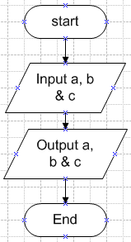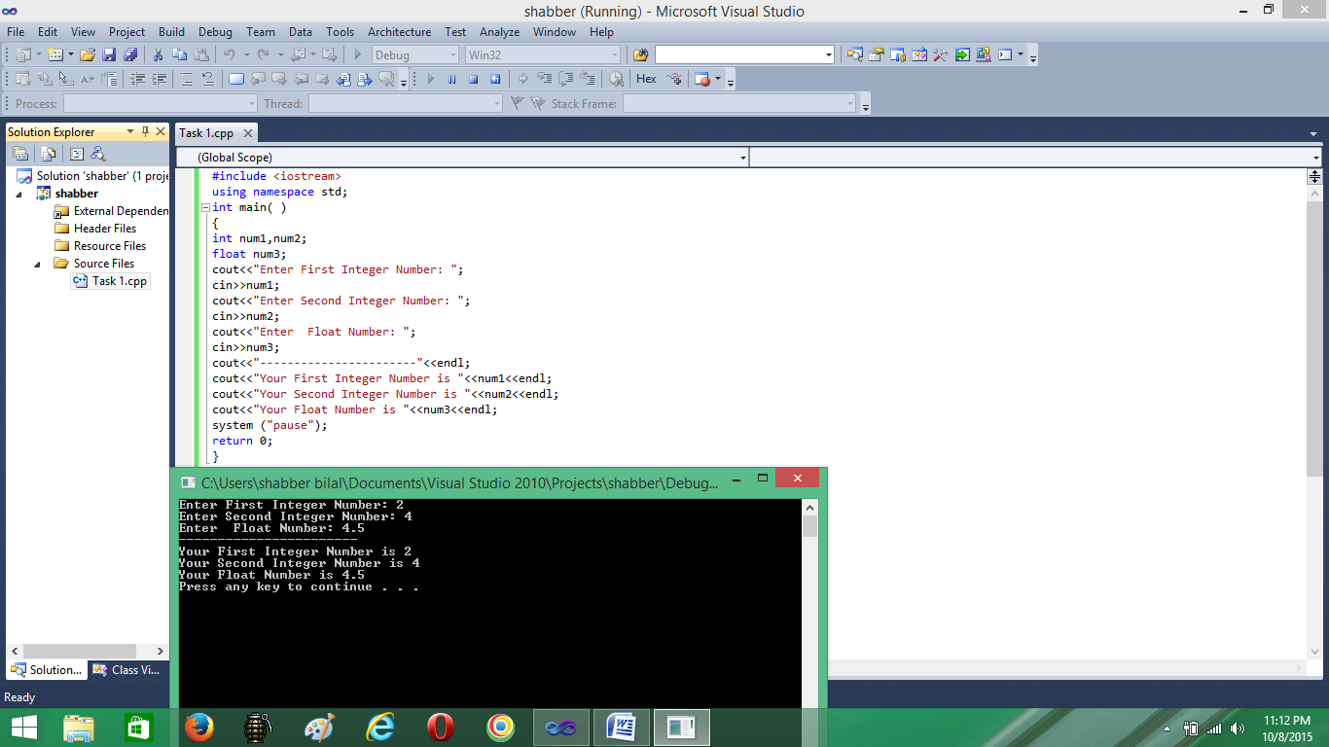**Objective: User Input Flow chart Programming**

Write a program that takes 3 values from user. Two values of integer and one value of float data type.

**Pseudo Code**

Start

Input a, b & c

Output a, b & c

End

**TASK 2**

**Objective: Flow chart Programming**

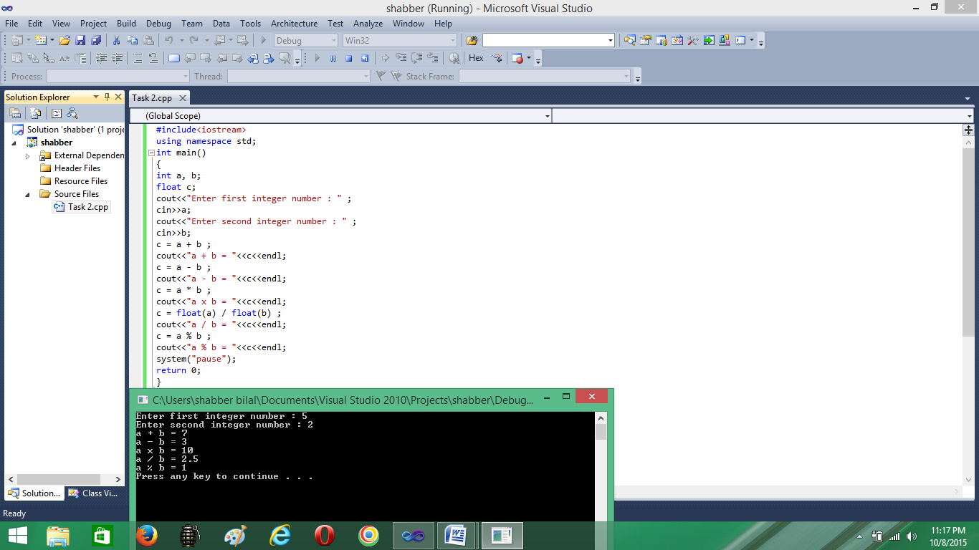**Arithmetic Operations**

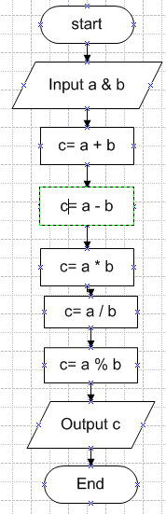Write a program that gets 2 integers input from user and store them in variables. Do the five basic Arithmetic Operations (+ , - , *, /, %) of the two numbers. Print the results of operations as below

**Pseudo Code**

Start

Input a & b

c= a+ b

c= a – b

c= a * b

c= a / b

c= a % b

Output c

End

**TASK 3**

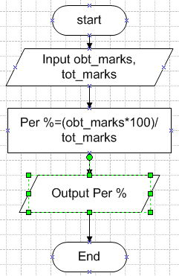 **Objective: Percentage Pseudo Code Flow chart**

Write a program that prompt Start

user to input course name, Input obt_marks, tot_marks

obtained marks and total marks. Per%=(obt_marks*100)/

Calculate the percentage using this tot_marks

formula Output Per%

*marks percentage = marks obtained* In Fundaments_Programming

*/ total * 100* course. You have secured Per%

and display the results as follows End

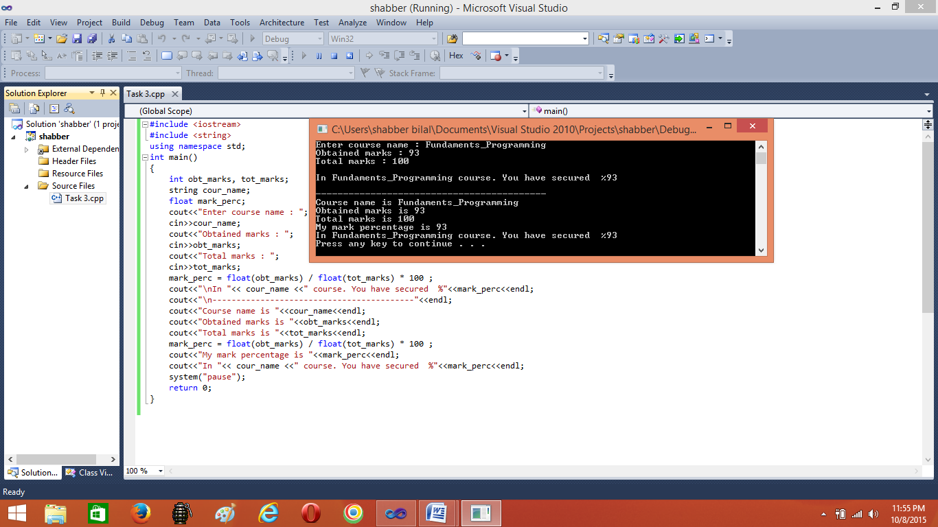 **Programming**

**TASK 4**

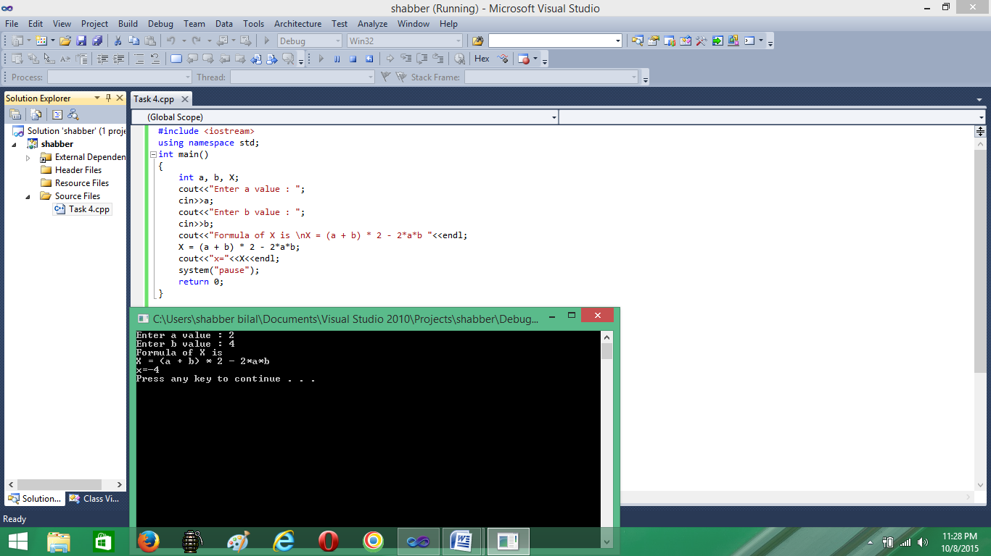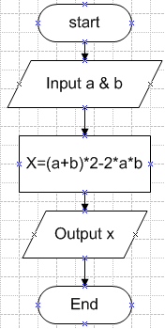**Objective: Calculating Value of X Flow chart Programming**

Write a program that finds the value of X by using given formula. Take values of a and b from user.

*X = (a + b)2 – 2ab*

**Pseudo Code**

Start

Input a & b

X= (a+ b)*2-2*a*b

Output x

End

**TASK 5**

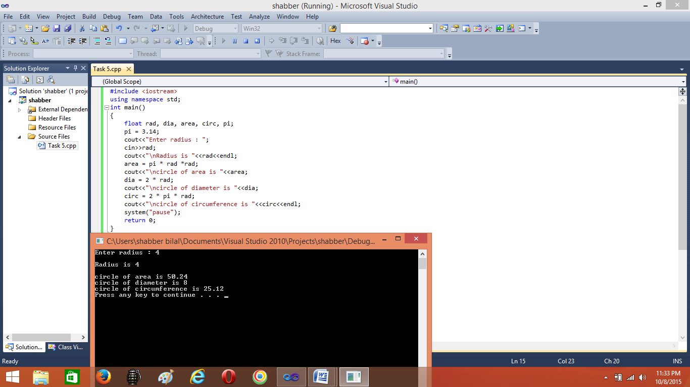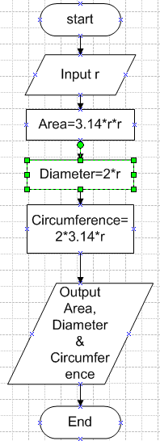**Objective: Circle calculations Flow chart Programming**

Write a program to calculate area, diameter and circumference of circle by using following formulae. Use Const and #define for value of $π$.Radius will be given by user

*Area $=πr^{2}$*

*Diameter =2*r*

*Circumference= $2π$ r*

**Pseudo Code**

Start

Input radius

Area= 3.14*radius*radius

Diameter= 2*radius

Circumfer=2*3.14*radius

Output Area, Diameter &

Circumference

End

**TASK 6**

**Objective: Flow chart**

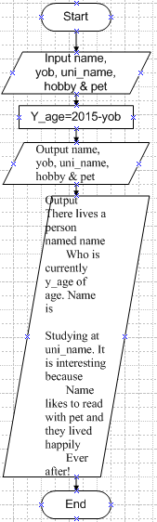Write a program that plays a word game with the user. The program should ask the user to enter the following: User’s name Year of birth (e.g. 1990) Name of university A favourite hobby A pet’s name .

**Pseudo Code**

Start

Input name, yob, uni_name, hooby & pet

y_age=2015-yob

Output name, yob, uni_name, hobby & pet

There lives a person named name

Who is currently y_age of age. Name is

Studying at uni_name. It is interesting because

Name likes to read with pet and they lived happily

Ever after!

End

**Programming** 